PROJECT1 (EE596)

Design and Simulation Problem

Instructor: Dr. Subhanshu Gupta

By: Mohammad Chahardori

ID:11632753

January 2019

The design of the differential amplifier is based on the final project of EE 576 and the value of W and L of transistor are the same. So, I don’t repeat the procedure of the amplifier design again here. The value of the compensation capacitor and resistor has been reduced since the feedback factor and the required phase margin and BW has been relax in this project. The applied common mode feedback circuit is a PMOS differential pair with diode connected load which has been injected to the part of the current source of the first stage. In fig 1a schematic of the circuit and DC operating voltage and current has been shown. In fig 1b the sizing of transistor and other components have been shown.

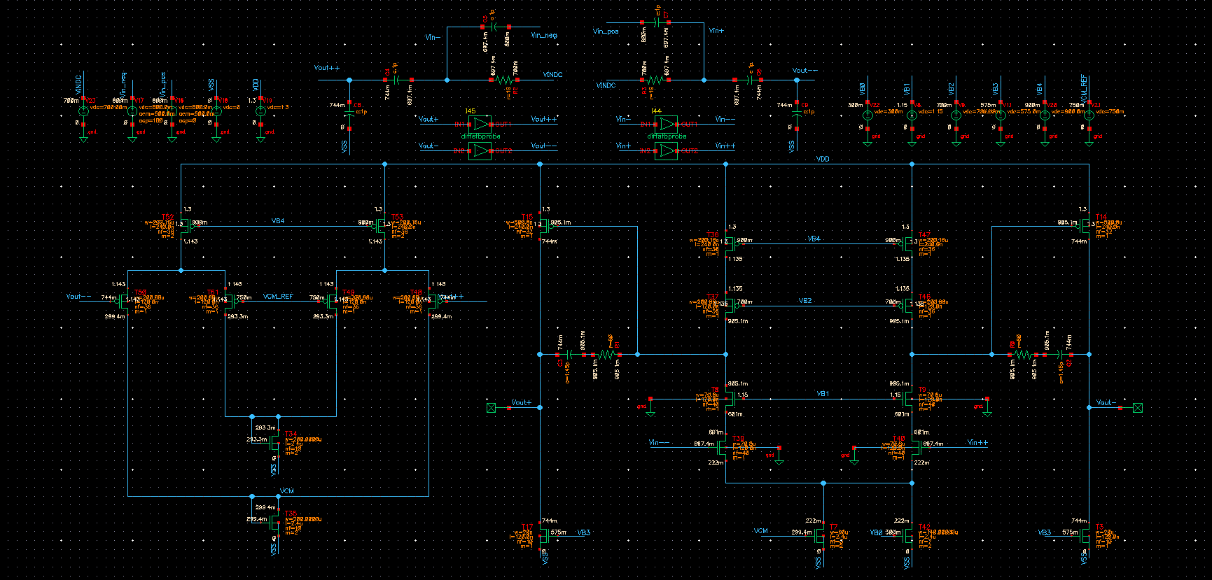
b
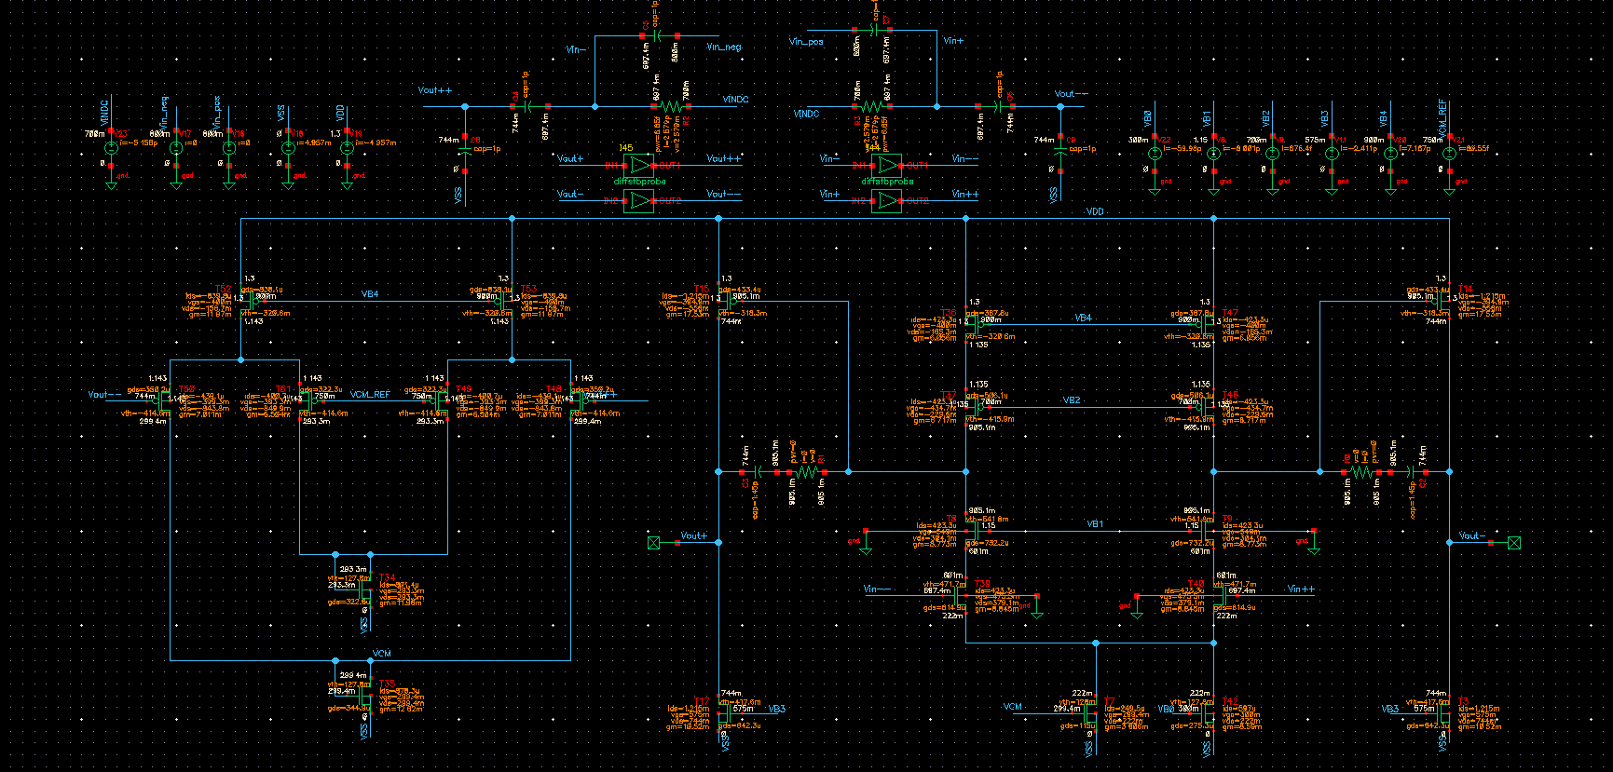
a
Fig.1. Schematic of the designed circuit. a. DC operating point b. Sizing of components

After simulation of the CM feedback loop gain it seems that the DC gain is about 65dB. To reduce this gain to required 55dB the common mode feed back voltage just injected to the transistor T7. In fact, T7 and T42 together act as current source of the first stage. However, T7 sizing is about 30 percent of whole sizing of the current source transistor which reduces the common mode feedback gain by about 10 dB. Reduction of the common mode feedback gain in addition to the lower required phase margin in common feedback which is 55 degree compare to differential mode which is 60 degree cause the compensation capacitor calculated from differential mode yields the required phase margin in common mode loop without changing the capacitor value.
In fig.2 and fig.3 the bode diagram of loop gain in differential mode and in common mode feedback loop are shown respectively. These two curves are achieved using STB simulation. Fig.2 shows the main differential loop has 60 dB gain in DC and 380MHz UGBW when the phase margin is 60 degree. Fig 3 shows that the common mode feedback loop acquires 55 dB gain at DC and UGBW of 75 MHz and phase margin of 55 degree. The designed amplifier satisfies the final determined values for the amplifier in the project.

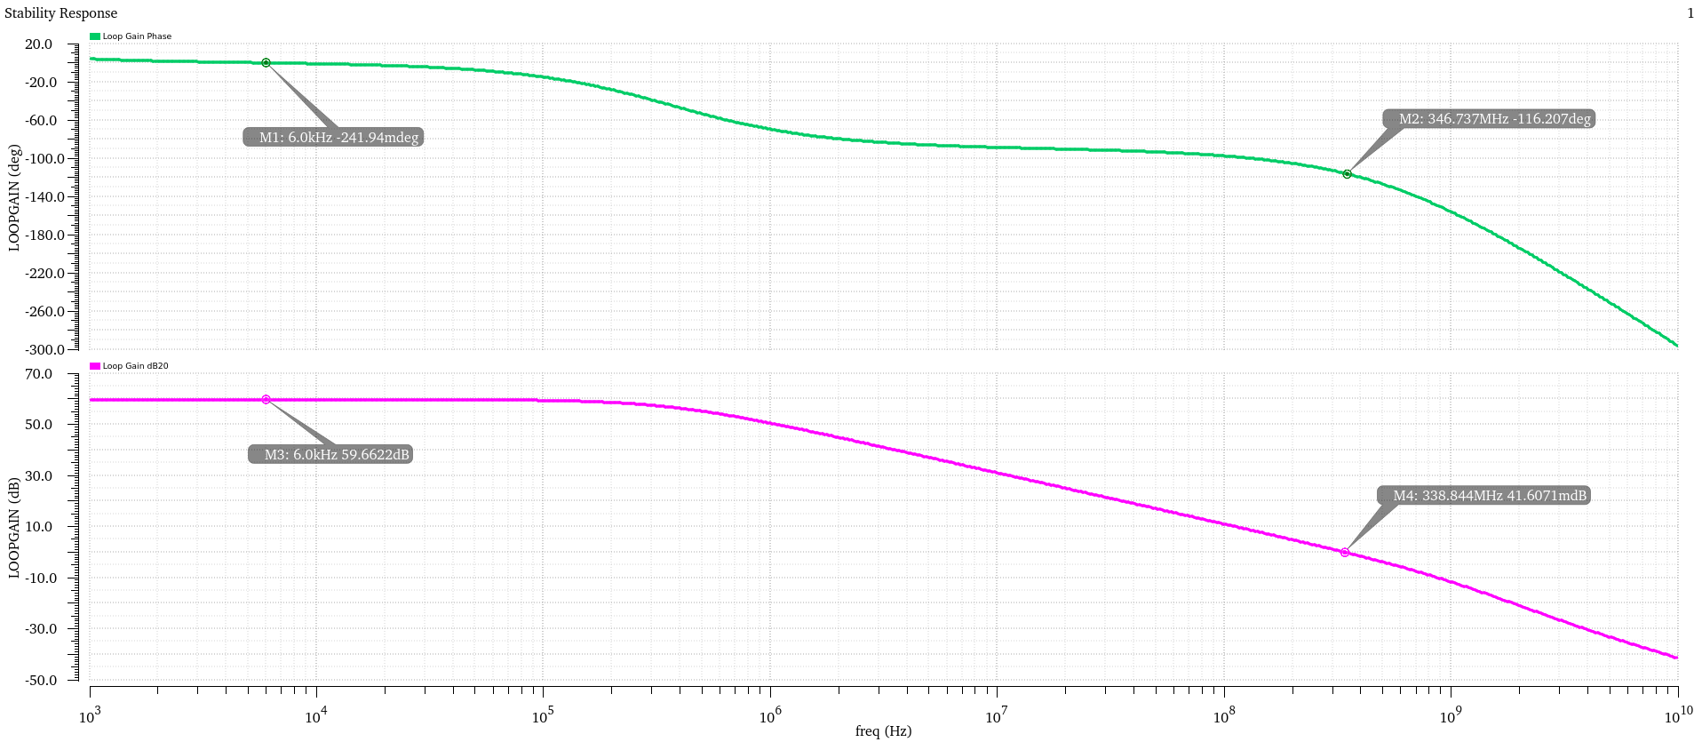
Fig.2 . differential loop gain and phase

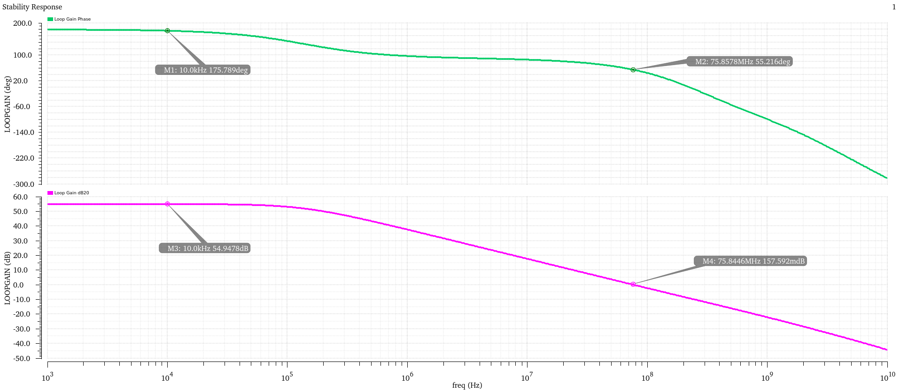
Fig.3 . Common Mode feedback loop gain and phase

In fig 4 the transient simulation of the amplifier when a sine input applied to the circuit is shown. Based on fig.4 the amplifier has more than 700 mV peak to peak swing in differential mode. Also, the closed loop gain is around 1 which shows the correct response of the closed loop circuit.

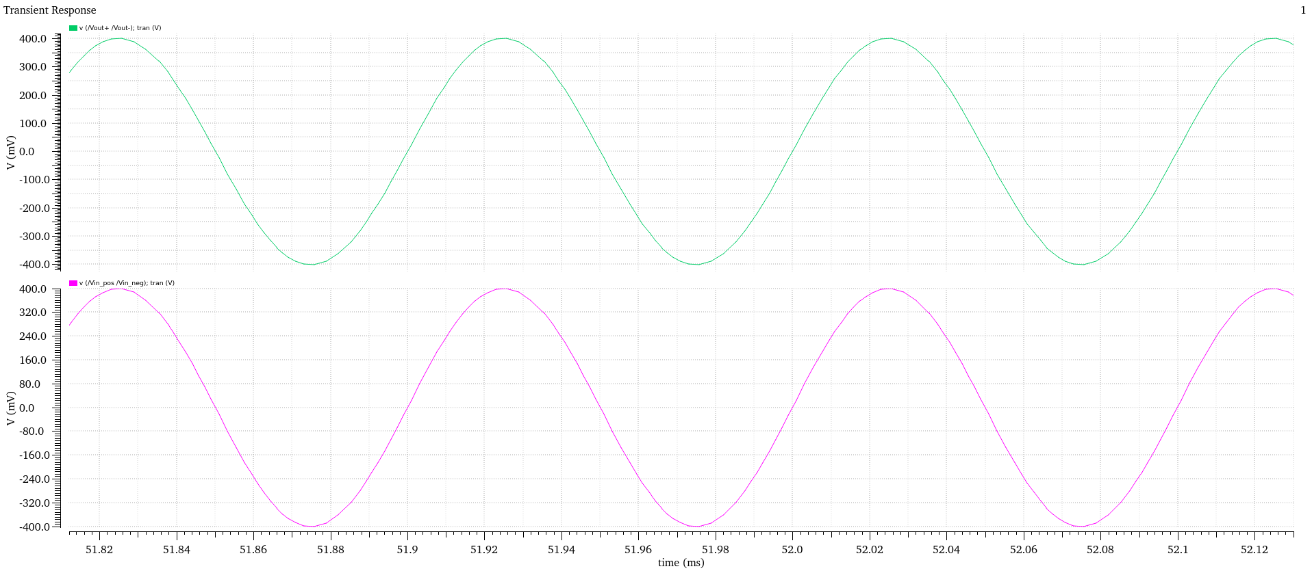
Fig.4 . transient response to a sine wave input

To determine the slew rate of the designed amplifier a 500mV square wave has been applied to the differential input of the closed loop amplifier. In fig 5 and Fig 6 the transient response to the large signal differential input are shown. Based on these figures both positive and negative slew rate are larger than 160V/us. Since the input voltage is very larger than differential input range the amplifier output becomes saturated to VDD and ground after 15ns. The achieved 160V/us is at least twice the required 80V/us slew rate in this project.

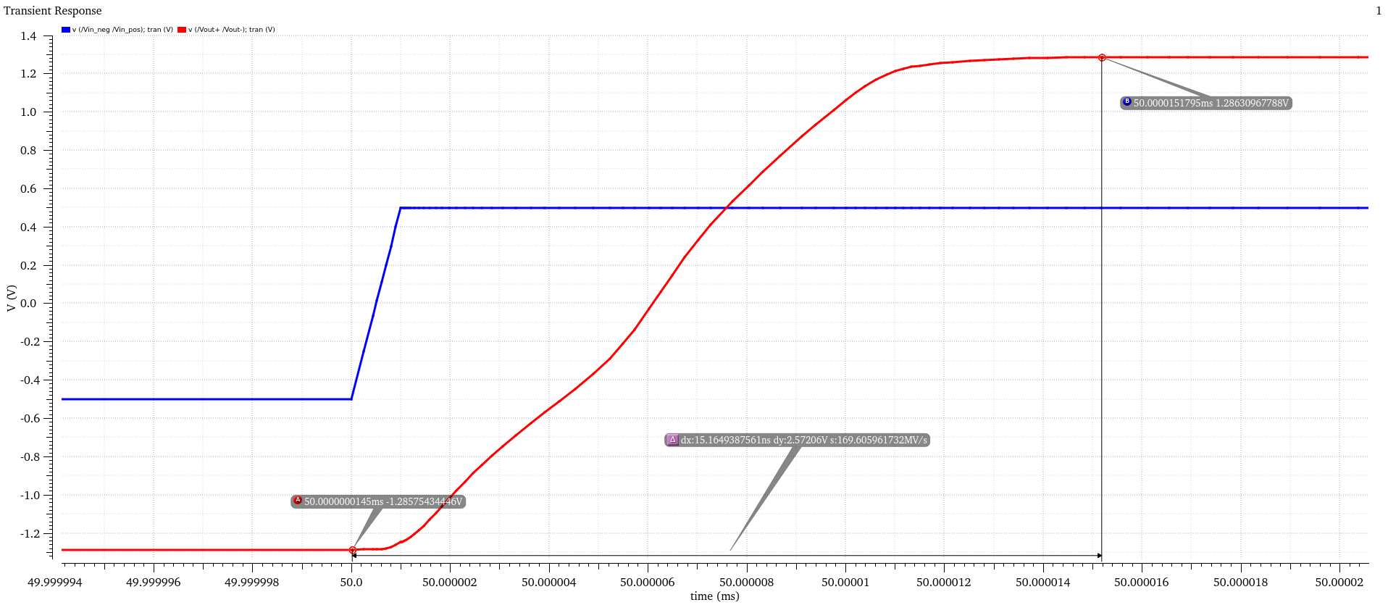
Fig.5 . transient response to a large signal differential positive pulse

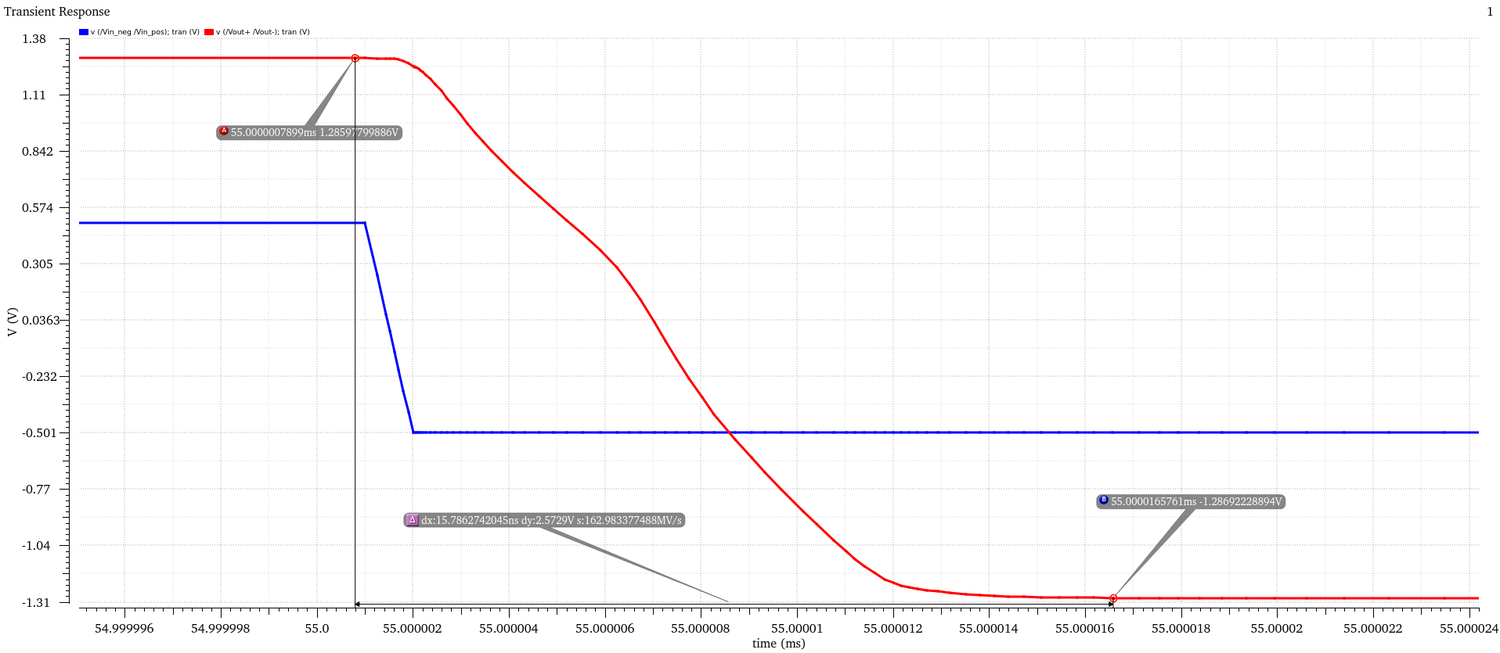
Fig 6 . transient response to a large signal differential negative pulse

Another required spec of the amplifier in this project is the PSRR. To simulate the amplifier PSRR an AC voltage source with 1-volt amplitude has been placed in series with the supply voltage VDD. And the output differential voltage of the amplifier using AC simulation has been derived. Since there is no random mismatch between component in the circuit, we expect very good PSRR in the structure. As shown in fig 7 the PSRR is better than 250dB in low frequency and it remains better than 200dB in high frequency.

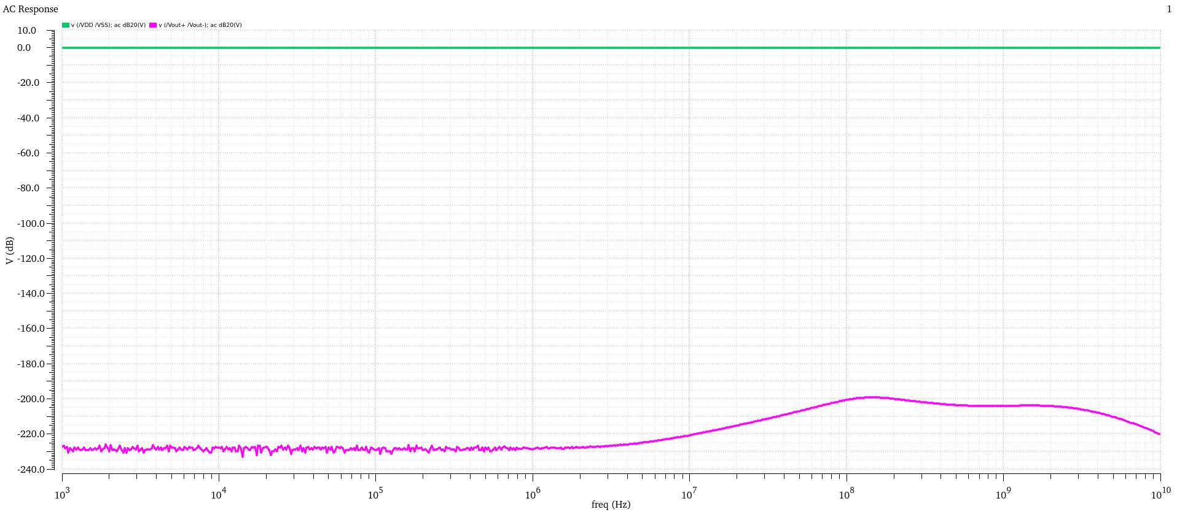
Fig.7 . Amplifier PSRR

The performance of the designed amplifier is summarized in Table I along with the required spec of amplifier in the project. As it is seen in fig1 the whole circuit consumes 4.985mA from 1.3V supply voltage VDD which yields 6.5mW power consumption. DC simulation of the circuit shows that the amplifier DC voltage track the CM feedback reference voltage from 800mV to 200mV with less than 15mV offset.
Based on the achieved results in the fig 1 to fig 8 and table I, The designed amplifier meets the required spec of the project which are assigned finally.

Parameter | Unit | Range | Simulation  Results | Notes
Supply voltage | V | 1.2 | 1.3 | As you given the permission
Power dissipation | mW | <40 | 6
DC Gain | dB | 60 | 60
fT | MHz | 1200 | 1 pF load on each output
Phase Margin | ° | >60 | 64
Output range over  which CMFB  operates | Vpk-pk,diff | >0.4 | 0.6
Input CM Range | Vpk-pk,diff | >0.4 | 0.6
Power Supply  Rejection Ratio | dB | >20 dB close-in  >40 dB far-out | 200
Slew Rate | V/µs | >80 | 160
Closed-loop DM gain | dB | >60 | 60
Closed-loop DM  Phase | ° | >55 | 64
Closed-loop UGB | MHz | >500 | 380 | As you given the permission
Closed-loop CM Gain | dB |  | 55
Closed-loop CM  Phase | ° | >55 | 55
Closed-loop CM UGB | MHz | >100 | 75 | As you given the permission
Table I

